Teaching mental mathematics from level 5 : Number

Place Value and Ordering

Instructions

1. This is an activity for pairs of pupils.

2. Copy the table onto a sheet of A3 paper. Copy a set of cards for each pair of pupils

3. Each paper should have a set of cards.

4. The cards all have answers which are either 0.04, 0.4, 4 or 40.

5. Place the cards against their answer

6. Sort the cards against each number to spell a word.

7. The four words give a sentence.

Key Questions / Plenary

1. Which ‘A’ was the ‘A’ in task?
(Alternatives ‘E’ in place, ‘E’ in value, ‘E’ in solved etc)
2. Which were the easy cards to sort? Why?
3. Which were the difficult cards to sort? Why?

0.04
0.4
4
40

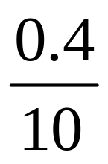 |  | 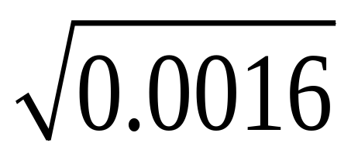
P |  | L
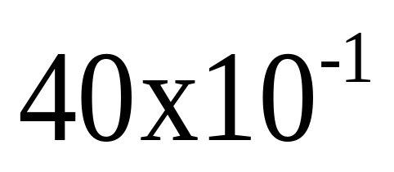 |  | 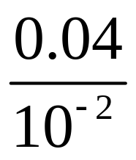
T |  | K

 |  | 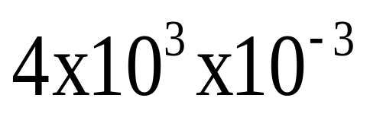
A |  | S
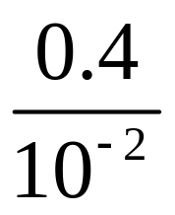 |  | 
S |  | O

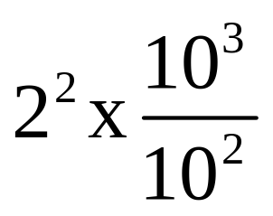 |  | 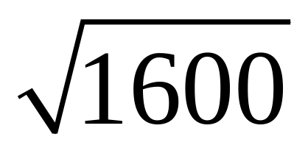
L |  | V
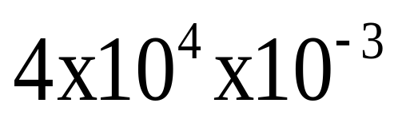 |  | 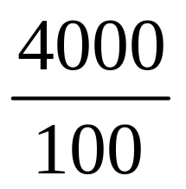
D |  | E

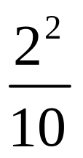 |  | 
L |  | A
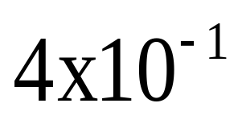 |  | 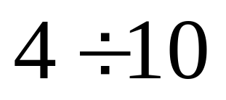
U |  | E

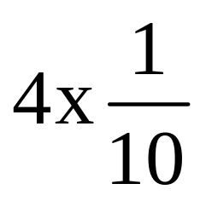 |  | 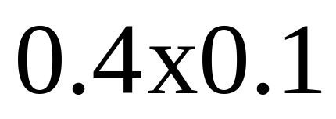
V |  | E
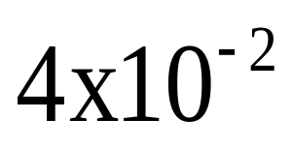 |  | 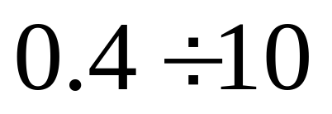
C |  | A

